Cost Action 356 MC meeting 24th -25th of September 2009 in Rhodes, Greece
Directions for Hotel & meeting place

The meeting place and accommodations will be held in the Mediterranean Hotel, in the City of Rhodes, Rhodes Island in Greece (the capital city of the island is called Rhodes, just like the island itself.
- The Hotel address is on 35, Cos street.
- Tel. +30 22410 24661
- Url: http://www.mediterranean.gr/html/home.html
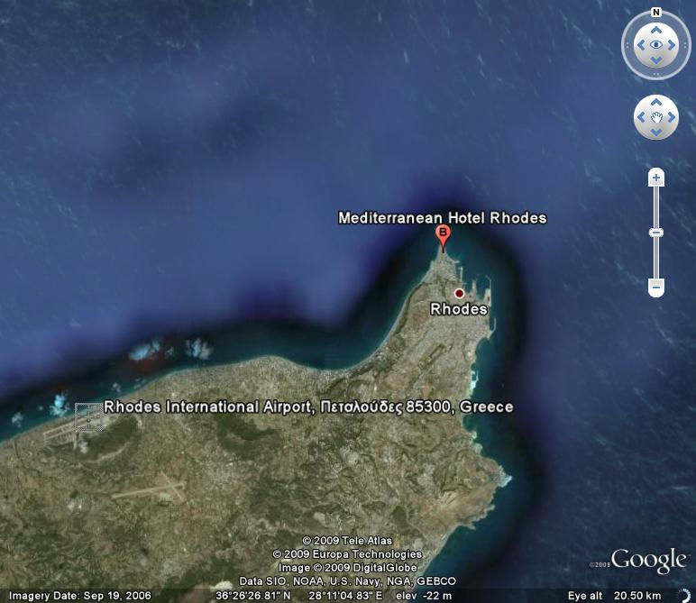
Once you arrive in the Rhodes International Airport “Diagoras” in order to reach the meeting place and accommodations at the Mediterranean Hotel, in the city of Rhodes, you can travel by Bus or taxi.
By Bus:
The Bus for Rhodes city centre departs 300 meters from the Air terminal; consult the airport’s information desk for current time tables. Take any bus from the airport terminal directed towards the city center (Rhodes city) and ask the driver to leave you off at the Mediterranean Hotel. The Airport is approximately 16 kilometers North, East of the hotel and city of Rhodes (see map on the left).
By Taxi:
The Airport is approximately 16 kilometers North East of the hotel. Taxis are available outside the terminal building; the fee is approximately 18 Euros. The city of Rhodes is a 20-minute drive and the hotel is located next to the sandy beach of the Aquarium (35, Cos Street).
